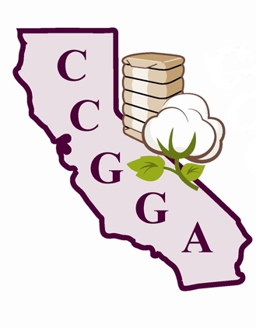
California Cotton Ginners & Growers Association

1785 N. Fine Avenue
Fresno, CA 93727
Phone: (559)252-0684
Fax: (559)252-0551

MEMO

To: Members & Interested Parties

From: Roger A. Isom

Date: March 16th, 2026

Subject: California Cotton Ginners & Growers Association, Supima & Western Cotton Shippers Association 2026 Annual Meetings

It’s time for the California Cotton Ginners and Growers Association’s 2026 Annual Meeting! This year it will be held in conjunction with Supima’s Annual Meeting and Western Cotton Shippers Association’s Annual Meeting and will be held Wednesday, May 20th at the International Agri-Center in Tulare, California. Registration and Continental Breakfast will begin at 7:30 am. The program will begin with Breakout Sessions at 8:30 am.

Attached is the Registration Form. Please complete and submit the form as soon as possible to allow the Association to make sure we can appropriately plan for the meeting. You can email the form to Michelle Franco at michelle@ccgga.org or fax it to our offices promptly at (559) 252-0551.

The cost of the event is free, but we encourage you to consider making a donation of at least $50 to the CCGGA Federal PAC or CCGGA State PAC to help protect California cotton at the state and federal levels. The CCGGA Federal PAC can only accept personal checks. Any corporate contributions must be made to the CCGGA State PAC.

Roger A. Isom
President/CEO

California Cotton Ginners and Growers Association
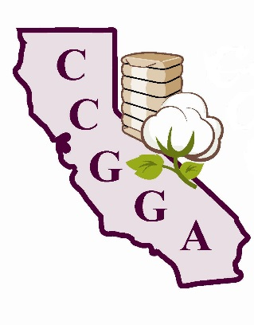
1785 N. Fine Avenue
Fresno, CA 93727
Phone: (559)252-0684
Fax: (559)252-0551

2026 CCGGA Annual Meeting Registration Form
Company Name: ______________________________________________

Attendee Name: ___________________________ email: __________________________
Ginners Track Growers Track

Attendee Name: ___________________________ email: __________________________
Ginners Track Growers Track

Attendee Name: ___________________________ email: __________________________
Ginners Track Growers Track

Attendee Name: ___________________________ email: __________________________
Ginners Track Growers Track

Attendee Name: ___________________________ email: __________________________
Ginners Track Growers Track

PAC Contribution: Federal State Amount $ __________

Ginners Track | - NCGA Report  - USDA ARS Gin Lab Update  - USDA-APHIS 2025 Cotton Classing Recap
Growers Track | - Cottonseed Bug/Cotton Jassid Update  - UCCE Update

Registration begins at 7:30 am.
Meeting starts at 8:30 am and concludes with a free lunch!

Please email this form to michelle@ccgga.org or
fax this form to (559) 252-0551 promptly.
This event is FREE, but you must register!

