Emergency Wildfire Smoke

When working outdoors during wildfires and where the current Air Quality Index (AQI) for airborne particulate matter 2.5 micrometers or smaller (PM2.5) is 151 or greater, and when it is reasonably anticipated that employees could be exposed to wildfire smoke. It is imperative that employees are protected from the effects of wildfire smoke, be sure to effectively communicate and train all employees on the following:

Identification of Harmful Exposures

Wildfire Smoke Effects:

The smoke from wildfires contains chemicals, gases and fine particles suspended in the air that present significant health hazard. These particles can irritate the lungs and cause serious health effects such as:
- reduced lung function
- bronchitis
- worsening of asthma
- heart failure

If you become ill or your co-worker needs to seek medical treatment for wildfire smoke inhalation, be sure to notify your supervisor and he/she will contact emergency medical services.

Communication of Wildfires:

Monitoring Air Quality Index (AQI) for PM2.5

The manager and or designated supervisor will monitor the daily AQI for PM2.5 in outdoor areas prior to workshift and periodically as needed by using one or more of the following websites:
- https://www.airnow.gov/
- www.valleyair.org/myraan - click on “Register with RAAN”

The easiest way to find the current and forecasted AQI for PM2.5 is to go to www.AirNow.gov and enter the zip code of the location where you will be working.

If you notice the air quality is getting worse, or you are suffering from symptoms due to air quality, be sure to notify your supervisor either by two-way radio, cell phone or other means of communication.

Protection from Wildfire Smoke when AQI for PM2.5 is 151 or greater

Examples of protective methods, if feasible, we may:
- relocate to another outdoor location where the current AQI for PM2.5 is lower,
- change or adjust work schedules,
- reduce work intensity of the work to help lower the breathing, or
- increase rest time and frequency

Use of Respirators

Respirators can be an effective way to protect employee health by reducing exposure to wildfire smoke, when they are properly selected and worn.

- Use of NIOSH approved particulate respirators, such as N95 masks to all employees for voluntary use
  - Surgical masks or items worn over the nose and mouth such as scarves, T-shirts, and bandannas will not provide protection against wildfire smoke. An N95 filtering facepiece respirator, shown in the image below, is the minimum level of protection for wildfire smoke.
- When the current AQI for PM2.5 is 151 or greater, it is encouraged that you wear the N95 respirators for voluntary use during outdoor work. If the current AQI is greater than 500, respirator use is required.
- A respirator should be used properly and kept clean. Read and follow the manufacturer's instructions on the respirator's use, maintenance, cleaning and care, along with any warnings regarding the respirator's limitations.
- Employees should keep track of their respirator so that they do not mistakenly use someone else's respirator.
How to properly put on, use, and maintain the respirators provided by the employer.
To get the most protection from a respirator, there must be a tight seal around the face. A respirator will provide much less protection if facial hair interferes with the seal. Loose-fitting powered air purifying respirators may be worn by people with facial hair since they do not have seals that are affected by facial hair.

For those who use an N95 or other filtering facepiece respirator mask that is made of filter material:
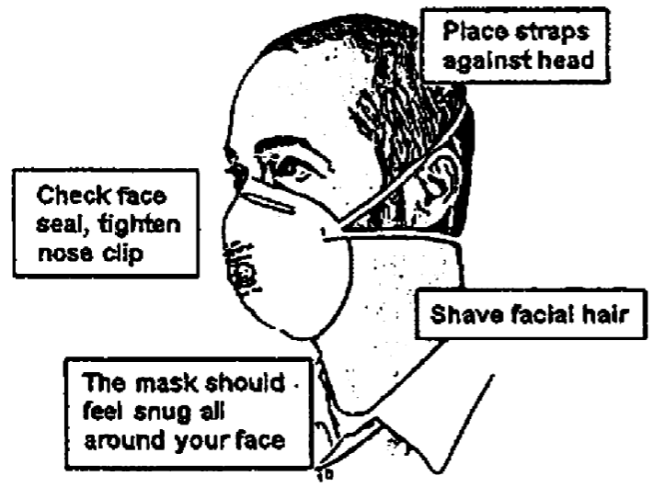
- Place the mask over the nose and under the chin, with one strap placed below the ears and one strap above.
- Pinch the metal part (if there is one) of the respirator over the top of the nose so it fits securely.
- For a respirator that relies on a tight seal to the face, check how well it seals to the face by following the manufacturer's instructions for user seal checks. Adjust the respirator if air leaks between the seal and the face. The more air leaks under the seal, the less protection the user receives.
- Filtering facepiece respirators are disposable respirators that cannot be cleaned or disinfected. A best practice is to replace filtering facepiece respirators at the beginning of each shift.
- If you have symptoms such as difficulty breathing, dizziness, or nausea, go to an area with cleaner air, take off the respirator, and get medical help.

