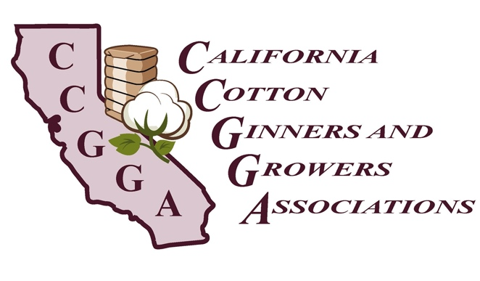
1785 N. Fine Avenue
Fresno, CA 93727
Telephone: 559.252.0684
Fax: 559.252.0551

MEMO

To: Members

From: Priscilla Rodriguez
Director of Regulatory Affairs

Date: February 27, 2019

Subject: Mandatory Retirement Program - CalSavers

In 2016, Governor Brown signed Senate Bill 1234 requiring the state’s Secure Choice Retirement Savings Investment Board to begin development of a workplace retirement savings program, known as CalSavers, for private sector workers whose employers do not offer a retirement plan. By June 30, 2022, all employers with five or more employees will be required to either provide a retirement plan for their workers or register for CalSavers and facilitate employees’ contributions to Individual Retirement Accounts.

CalSavers broadly covers all employees. Accordingly, seasonal employees are not exempt from CalSavers. Employers who maintain retirement plans are already exempt from CalSavers even if their seasonal employees do not qualify for those plans due to lack of service days (eligibility requirements). This apparent loophole may be revisited by the Legislature. If you have a current retirement plan, we highly recommend you ensure the eligibility requirements of your retirement plan are being met or changed accordingly. (e.g. one year of employment, full time, 21 years of age)

If you would like to be proactive, you can still enroll into CalSavers even if you have a current retirement plan.

Attached you will find a handout that provides additional information about the requirements of CalSavers.

Deadlines for compliance vary according to the size of the business.
CalSavers compliance deadlines, by business size.
Size of Business | Deadline
Over 100 employees | June 30, 2020
Over 50 employees | June 30, 2021
5 or more employees | June 30, 2022

Should you have any questions, please feel free to contact our office at (559)252-0684.

